A Residential Christian Community
at St Thomas’s, Ipswich, Suffolk

Community Prayer Mission
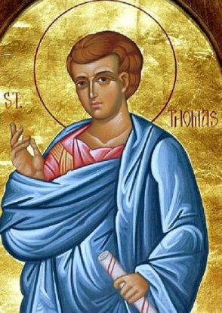
Seeking New Members!

Would you like to explore living in a small community with others who are searching for God and a way of life integrating faith and action?
Would you welcome a space to develop your prayer life, share your journey of faith with others and be active in God’s loving involvement in the world?
Are you interested in exploring God’s call for you in your life?

come and pray with us come and join us

St Thomas’s, Ipswich is a Church of England parish whose Priest in Charge, the Revd Jutta Brueck, brings experience of living in and supporting Christian residential communities. She has a calling to develop a new monastic community that would be open to Christians and seekers of all backgrounds, drawing on the experience of ancient and present religious communities.

Since February 2016 people of different backgrounds and ages have attended fortnightly prayer meetings. In June, the first residential member moved into the Vicarage. There is space for three further residents, and our rhythm of life will take into account the diverse circumstances of members, which may include students, people exploring a call, people in employment or a couple. There are also a number of non-resident Community members. We welcome enquiries from anyone who is excited by our vision, and we would be delighted to hear from you.
Our vision is to create a small residential Christian community in North West Ipswich, located at St. Thomas’s Vicarage. The community will be rooted in a regular pattern of prayer, as we want to be a prayerful presence in our neighbourhood. We are also developing a rhythm of study, eating together, hospitality and mutual support, and we aim to engage in God’s mission in the wider community, for example through work with children, young people and those who are isolated. The area includes the Whitehouse estate with many families, a large primary school and a secondary school, and we would seek to make a difference in their lives.

To find out more, and to explore whether you could be part of this community, please contact:
The Revd Jutta Brueck, email jutta.brueck@cofesuffolk.org tel 01473 743341
or Helen Waters, email st.thomascommunityipswich@gmail.com or see
www.stthomasipswich.org.uk or www.facebook.com/St-Thomas-Ipswich-Developing-a-residential-community

Please do join us at any of our Community prayer meetings (bring some food to share):
Dates: 18 August, 7 and 22 September, 5 and 20 October, 1 and 16 November @ 7.00-9.00pm
St. Thomas Vicarage, 102 Cromer Road, IP1 5EP

This project is supported by St Thomas’s PCC and the Diocese of St Edmundsbury and Ipswich.

